Capacity of water level sensor commercial for water tank, their components, and their prices
Capacity of water level sensor commercial for water tank in local and international market.
- Submersible Water Level Sensor with wireless monitoring system (International):
The Submersible Water Level Sensor is a general purpose submersible hydrostatic level transmitter. It adopts imported high quality piezoresistive sensor, robust 316L stainless steel housing and a hydrometric cable with the ventilation tube make it dependable and cost effective solution for a wide variety of industrial level measurement applications. It can keep working fine in liquids for more than ten years.
Specification
Measuring Medium: Water
Level Range:0-100m
Cable:100m PE vented cable
Signal Output:4-20mA
Power Supply:12-30Vdc
Accuracy:0.5%FS
Working Temp Span:-10~60C
Housing material: Stainless steel 316L
Water Proof: IP68
Application
●Hydrostatic level measurement
●Water pressure level measurement
●Deep well and groundwater monitoring
●Sea water level measurement and control
●Borehole water level measurement
●Level measurement in pumping station
Wireless Monitoring System
4G RTU module
Power Supply:12-28Vdc
Other Remarks:3 channels analog input
Input signal: 4-20mA
4G wireless signal access

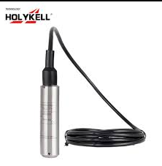
Figure 1: Submersible Water Level Sensor with wireless monitoring system
Website:
https://jescopakistan.pk/products/submersible-water-level-sensor-with-wireless-monitoring-system
- High Precision 4 to 20mA Water Level Sensor with LCD Display and 0 to 10m Range – GAOTek(International)

Description

Technical Specifications
Range | 0m to 10m (32.8 ft)
Signal | 4mA to 20mA
Medium | Water
Precision | ±1mm
Installation Mode | Screw thread
Power Supply | 24v

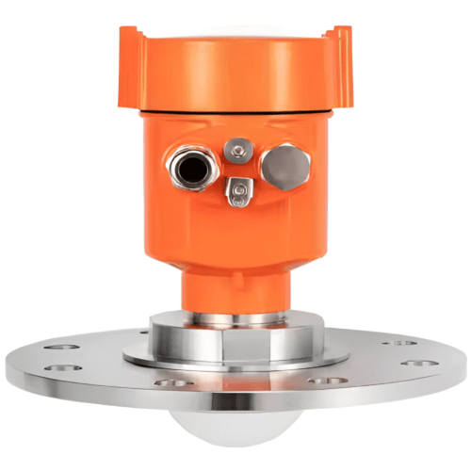
Figure 2: High Precision 4 to 20mA Water Level Sensor with LCD Display and 0 to 10m Range – GAOTek
Website:
https://gaotek.com/product/high-precision-4-to-20ma-water-level-sensor-with-lcd-display-and-0-to-10m-range-gaotek/
- FST700-1000 Submersible 4 20mA Piezo 2wire Water Tank Level Sensor in Pakistan(Local)
- Parameter | - Specification
Measurement Range | 0–1 m to 0–200 m (customizable)
Output Signal | 4–20 mA / 0–5V / 0–10V (depends on model)
Accuracy | ±0.25% to ±0.5% FS
Power Supply | 12–36 V DC
Material | Stainless Steel 316L
Working Temperature | −10°C to +80°C
Protection | IP68 (fully submersible)
Cable Type | Waterproof vented cable with air tube for pressure compensation
Cable Length (Standard) | 10 meters (~32.8 feet) by default
Optional Lengths | Can be ordered in 5 m, 10 m, 15 m, 20 m, 30 m, or 50 m versions

Price:
US$39.00 - 129.00
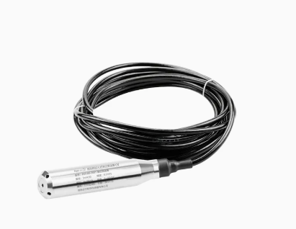
Figure 3: FST700-1000 Submersible 4 20mA Piezo 2wire Water Tank Level Sensor in Pakistan
Website:
https://firstsensor.en.made-in-china.com/product/oyIQLRsUbSVT/China-FST700-1000-Submersible-4-20mA-Piezo-2wire-Water-Tank-Level-Sensor-in-Pakistan.html
- Ground Water Level Measurement Transmitter Sensor 24VDC 4-20MA - MY-136(Local)
The measurement depth (in feet or meters) of such a sensor depends on its model number, which usually appears on the label. Unfortunately, the text on the label is not entirely clear in your image — but based on its size and cable type, this sensor typically measures:
- 0–5 meters (≈16.4 feet).
Specification | Details
Model | TL-136 / MY-136
Power Supply | 24𝑉𝐷𝐶
Output Signal | 4−20𝑚𝐴
Measuring Medium | Water and non-corrosive liquids
Sensor | High-precision silicon diffusion sensor
Material | 304 stainless steels
Protection Level | IP68
Measurement Accuracy | 0.2%FS - 0.5% FS (conventional)
Temperature Compensation | Yes, for −10 to 70 °C
Ambient Temperature | −40 to 80 °C
Medium Temperature | −40 to 70 °C
Long-term Stability | ±0.2%FS / year
Air Guide Cable Length | Typically, 5 meters
Price:
PKR16,750
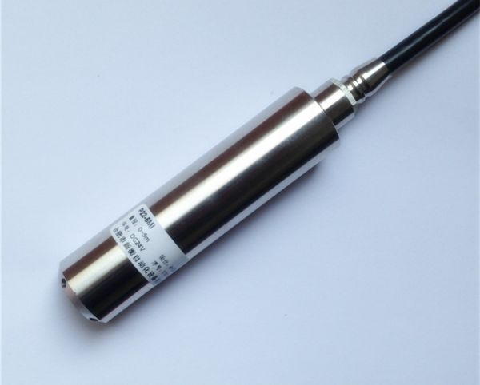
Figure 4 :Ground Water Level Measurement Transmitter Sensor 24VDC 4-20MA - MY-136
Website:
https://instock.pk/ground-water-level-measurement-transmitter-sensor-4-20ma.html

